Power BI Lab 4 Report
Advanced Reporting Concepts
Tamar Tutisani

RLS
RLS allows us to restrict data visibility based on user roles. I created three security roles in the model:
- Sales Manager North - Sees only North America region sales
- Sales Manager Europe - Sees only Europe region sales
- Admin - Sees all data
Configuration Method is shown in Screenshots 1, 2 and 3.
Security Description:
- Sales Managers see only their regional data to maintain confidentiality
- Admin role bypasses filters for oversight and reporting
- Roles were validated in Power BI Desktop before publishing
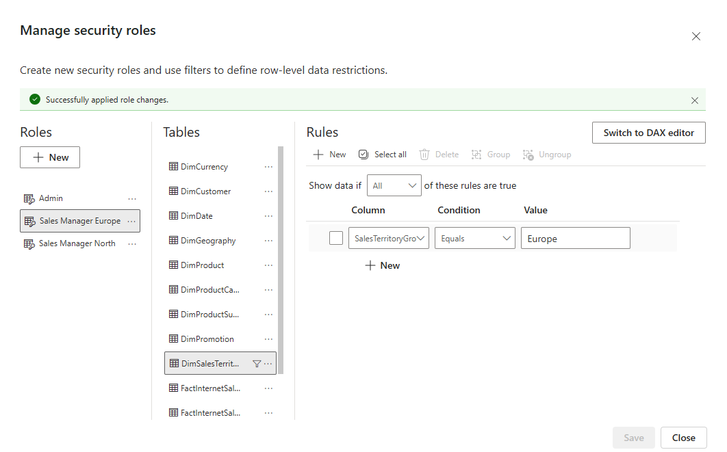
Screenshot 1. Sales Manager Europe Role

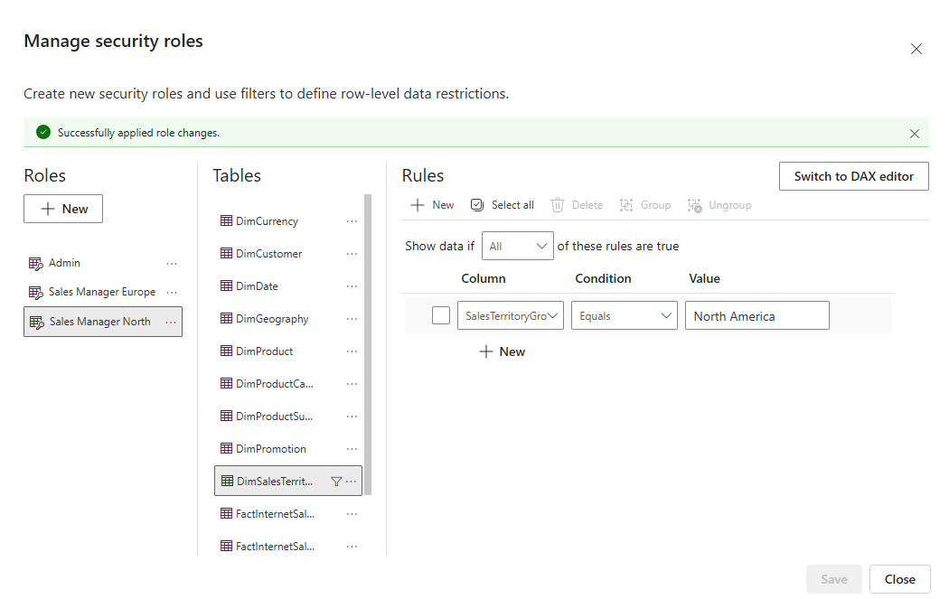
Screenshot 2. Sales Manager North Role

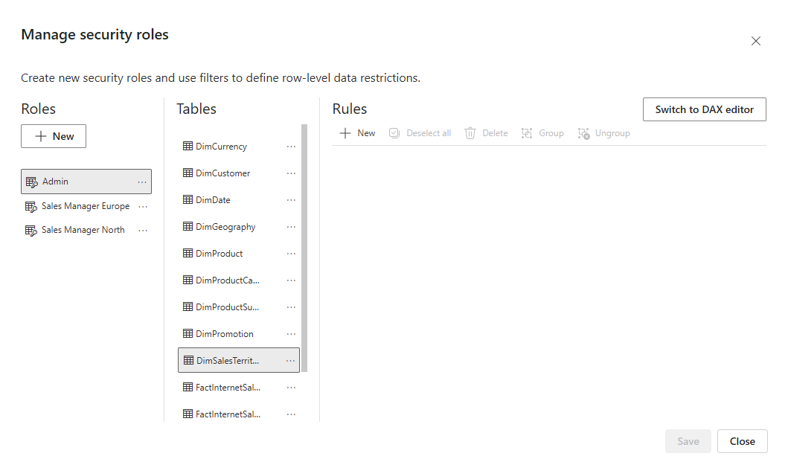
Screenshot 3. Admin Role
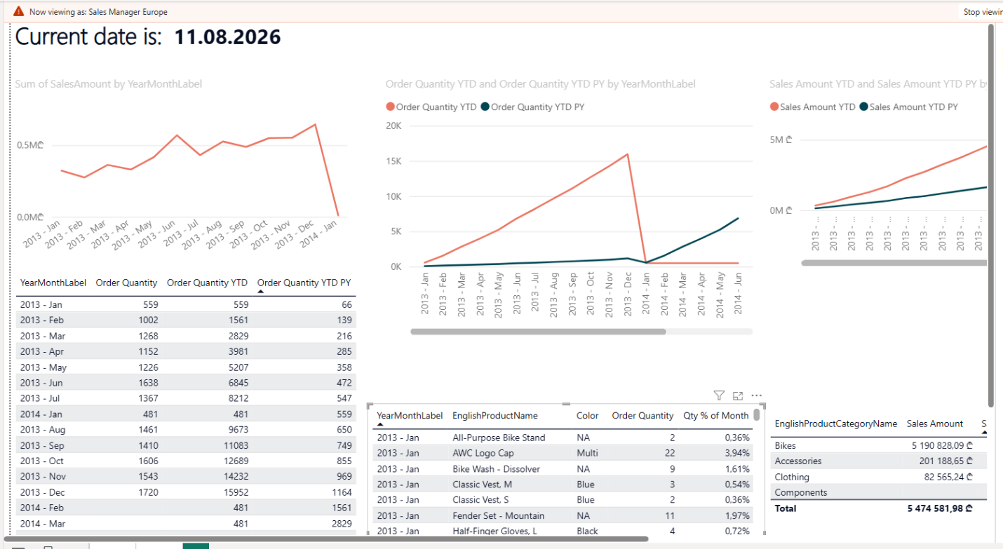
Screenshot 4. Viewing as Sales Manager Europe

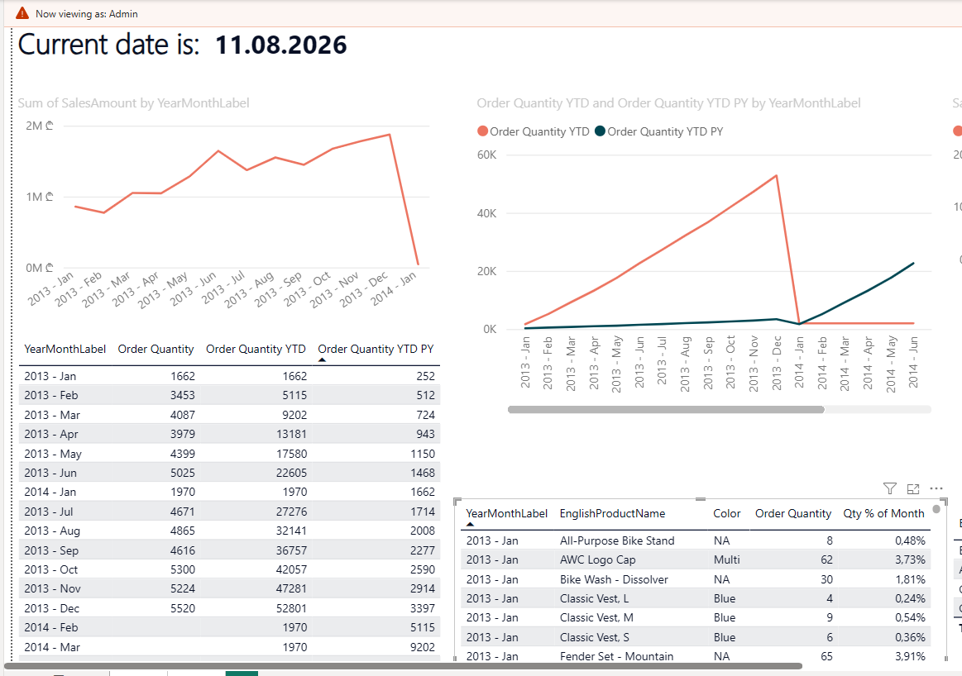
Screenshot 5. Viewing as Admin

BOOKMARKS & BUTTONS
Bookmarks and buttons were used to create an interactive experience allowing users to switch between two different visualizations without navigating away from the page. This feature improves report usability by presenting multiple analytical perspectives in a compact, organized manner.
What Was Built
Two visuals were created and positioned in the same location on the report page:
- A horizontal bar chart displaying sales amounts by product category
- A geographic map showing sales distribution across sales territories
Both visuals were sized identically and layered on top of each other to occupy the same space on the page.
Configuration Method
The implementation used Power BI's Selections pane combined with bookmarks:
- Both visuals were created and positioned to overlap completely
- The Selections pane (View tab -> Selections) was opened to manage visual visibility
- Two bookmarks were created to capture different visibility states:
  - "Bar Chart View" bookmark: Bar chart visible, map hidden
  - "Map View" bookmark: Map visible, bar chart hidden
- The Selections pane's eye icon was used to toggle visibility before saving each bookmark state
Why This Approach
Using the Selections pane is more reliable than attempting to hide visuals through context menus, as it provides direct control over visual visibility. Bookmarks capture these visibility states, allowing users to return to saved views instantly. This approach is flexible and doesn't require complex DAX or measure logic.
Users can click between the two bookmarks to instantly switch between viewing sales by product category (bar chart) and by geographic territory (map). This allows exploration of the same data from different perspectives without page navigation.
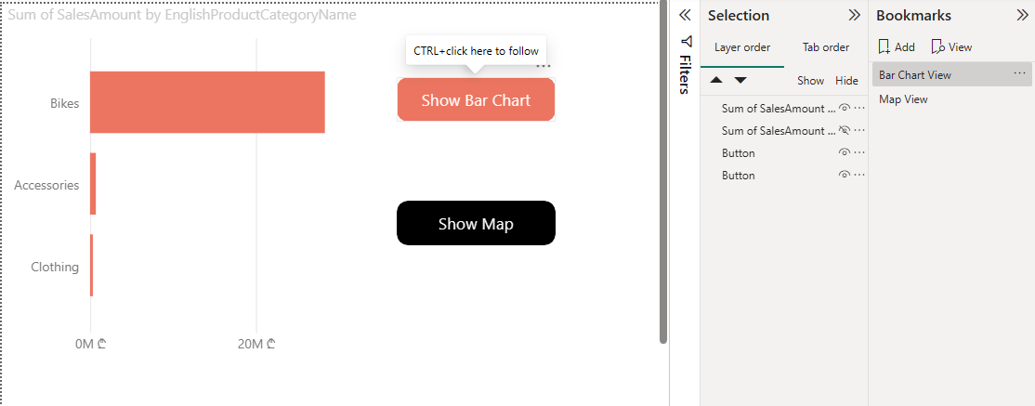
Screenshot 6. Bar Chart View bookmark active - bar chart visible
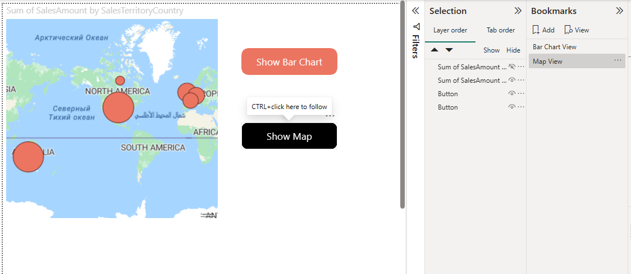
Screenshot 7. Map View bookmark active - map visible

DYNAMIC TIME PERIOD SWITCHING (MTD/QTD/YTD)
On the YTD calculation page, I added the ability to switch between Month-To-Date (MTD), Quarter-To-Date (QTD), and Year-To-Date (YTD) views.
What I Built:
- Created three measures using time intelligence functions:
  - MTD Sales = TOTALMTD([Sales Amount], DimDate[FullDateAlternateKey])
  - QTD Sales = TOTALQTD([Sales Amount], DimDate[FullDateAlternateKey])
  - YTD Sales = TOTALYTD([Sales Amount], DimDate[FullDateAlternateKey])
- Created a "TimePeriod" table with values: MTD, QTD, YTD
- Created a dynamic measure using SWITCH logic:
Selected Time Period = SWITCH(
SELECTEDVALUE(TimePeriod[TimePeriod]),
"MTD", [MTD Sales],
"QTD", [QTD Sales],
"YTD", [YTD Sales],
[YTD Sales]
)
- Added a Slicer visual with TimePeriod field for user selection
- Updated the chart to use [Selected Time Period]
Why This Approach:
Using SWITCH with SELECTEDVALUE is flexible and scalable. It allows users to dynamically change the time calculation without modifying the DAX or refreshing the report.
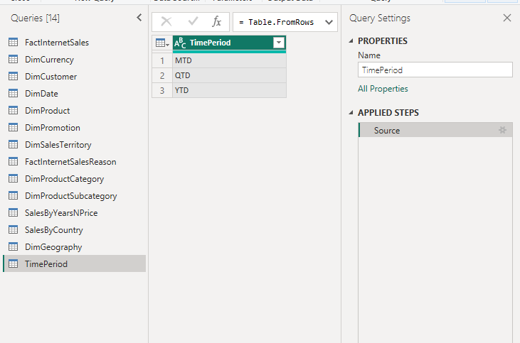
Screenshot 8. TimePeriod Table
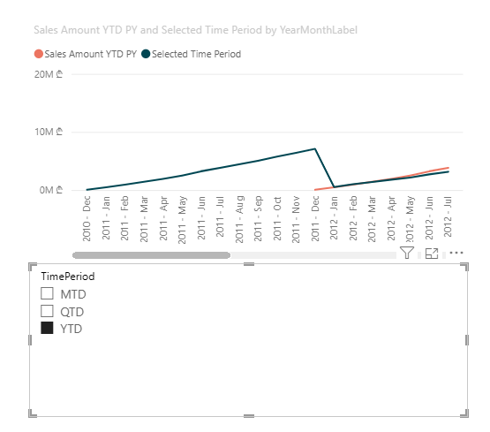
Screenshot 9. Chart with slicer showing YTD view

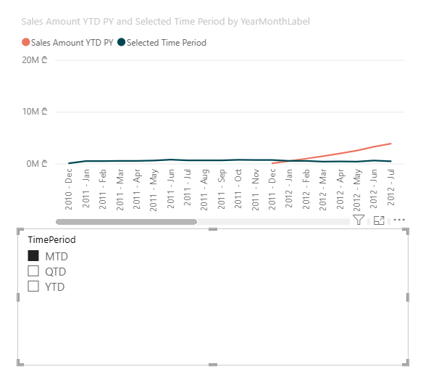
Screenshot 10. Chart with slicer showing MTD view
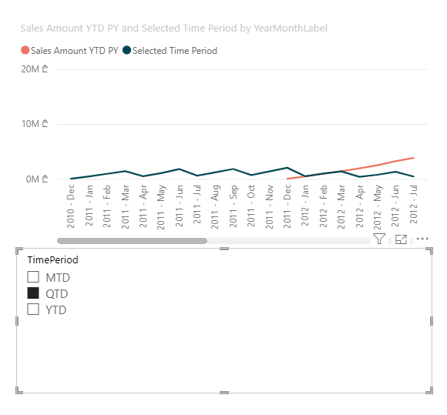
Screenshot 11. Chart with slicer showing QTD view

DECOMPOSITION TREE
The Decomposition Tree is a visual that lets users drill down through multiple dimensions to explore data and find patterns.
Configuration:
- Analyze: Sales Amount (the metric to understand)
- Explain By (3 independent variables):
- EnglishProductCategoryName (Product Category)
- SalesTerritoryRegion (Region)
- CalendarYear (Year)
How It Works:
- Root node shows total sales across the entire dataset
- User clicks the + button to see data split by Category
- Drilling further splits by Region to show regional sales within each category
- Drilling again splits by Year to show year-over-year trends
- Each path tells a story about what drives sales
User Value:
This visual is ideal for ad-hoc exploration and answering questions like "Why are sales high/low?" Users can navigate dimensions in any order without pre-planned drill-down paths.
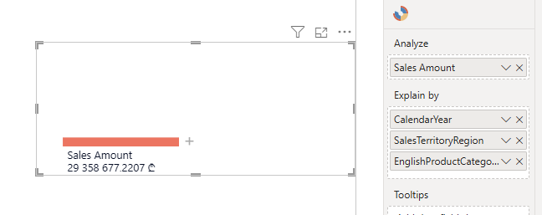
Screenshot 12. Added visual and its variables

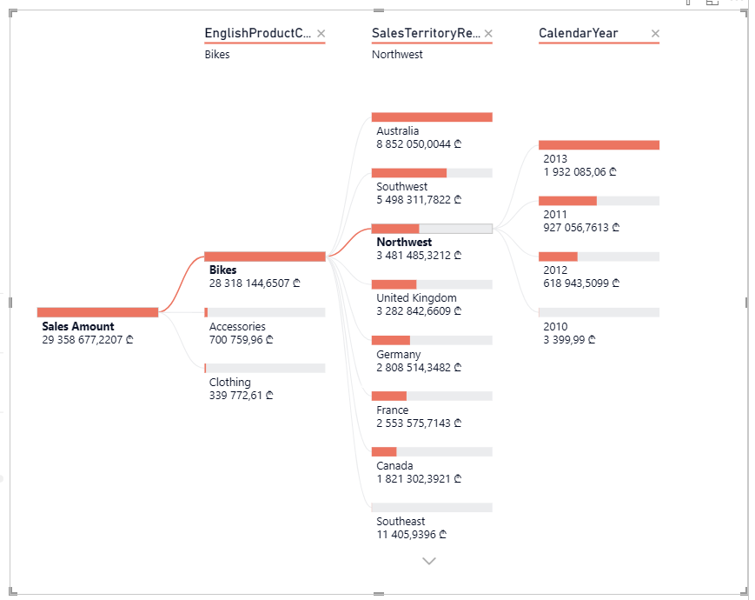
Screenshot 13. Decomposition Tree

CUSTOM TOOLTIP
Custom tooltips provide rich, contextual information when users hover over visuals without cluttering the main report.
What Was Built
The tooltip page contains three visuals designed to give deeper insights into each data point:
- A card showing Order Quantity (total units ordered)
- A card showing Average Order Value (Sales Amount divided by Order Quantity)
- A bar chart displaying sales breakdown by product subcategory
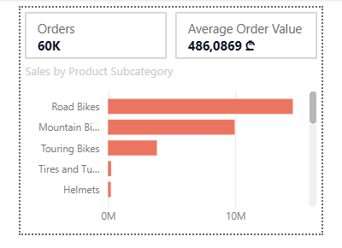
Screenshot 14. Tooltip
These metrics complement the decomposition tree's primary analysis without duplication.

Configuration Method
- Created a new report page with tooltip canvas size (320px × 240px)
- Added three visuals to the tooltip page:
- Order Quantity card
- Average Order Value card (calculated as Sales Amount / Order Quantity)
- Horizontal bar chart showing sales by product subcategory
- Enabled the page as a tooltip via Page Information settings
- Applied the tooltip to main visuals by setting Tooltips Type to "Report page" and selecting the Tooltip Page
Why This Approach
Order Quantity and Average Order Value provide actionable insights that sales amount alone cannot convey. For example, high sales could result from high volume or high prices—these metrics clarify which. The subcategory breakdown reveals which product types drive sales within a selected category, adding another layer of analytical depth.
User Experience
When users hover over any data point in the decomposition tree, the tooltip appears showing order volume, price per unit, and product mix. This allows users to understand not just how much was sold, but how many units at what average price and which product types contributed to that performance.
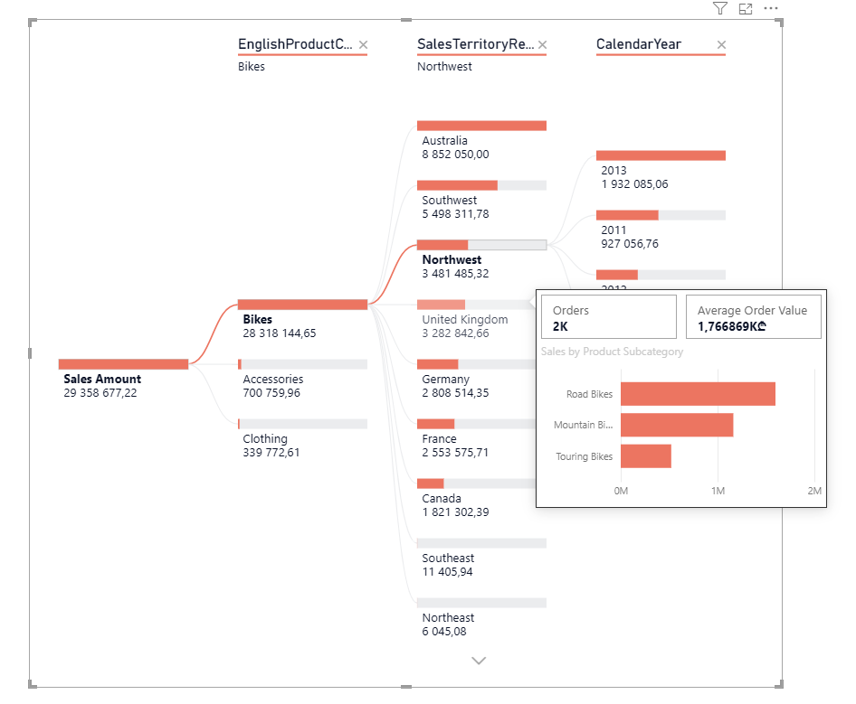
Screenshot 15. Tooltip in action

CUSTOM R SCRIPT VISUAL
A custom visual was created using R scripting to analyze sales amount distribution across all orders. Rather than using Power BI's default visuals, an R-based histogram provides more detailed statistical analysis and customization options that standard visuals cannot offer.
What Was Built
A histogram visual displaying the distribution of sales amounts across individual orders. The visual includes:
- A frequency histogram showing how many orders fall into each sales amount range
- A red dashed line indicating the mean sales amount
- A legend displaying the calculated mean value
- Grid lines for easier data reading
Method Chosen: R Script Visual
Power BI's R scripting capability allows integration of custom R code to create visualizations beyond default chart types. The implementation process involved:
- Inserting an R script visual from the Visualizations pane
- Adding data fields to the Values area (OrderQuantity, SalesAmount, YearMonthLabel)
- Writing R code using base graphics to create a histogram with statistical overlays
- Executing the script to render the custom visualization
Why This Approach
Standard Power BI visuals like bar charts show individual data points, but they don't reveal underlying statistical distributions. A histogram groups sales amounts into ranges (bins) and shows frequency, making patterns immediately visible. The mean line overlay provides context, users can quickly see whether most orders cluster above or below average sales value.
Usage and Benefits
Distribution Analysis: The histogram reveals that sales amounts follow a right-skewed distribution, with most orders clustered in the lower-to-mid range and fewer high-value orders.

Statistical Context: The mean at 772,597 ₾ is influenced by large outlier orders. The median line provides a better representation of a typical order value, as the right-skewed distribution shows most orders fall below the mean due to a few high-value orders pulling the average upward.
Code Used
# Clean data
clean_data <- dataset[complete.cases(dataset), ]

# Create histogram
hist(clean_data$SalesAmount,
main="Sales Amount Distribution Across Orders",
xlab="Sales Amount (₾)",
ylab="Frequency (Number of Orders)",
col="steelblue",
border="darkblue",
breaks=30,
las=1)

# Calculate mean and median
mean_sales <- mean(clean_data$SalesAmount, na.rm=TRUE)
median_sales <- median(clean_data$SalesAmount, na.rm=TRUE)

# Add vertical lines
abline(v=mean_sales, col="red", lwd=2, lty=2)
abline(v=median_sales, col="green", lwd=2, lty=2)

# Add legend
legend("topright",
legend=c(paste("Mean: ₾ ", round(mean_sales, 0)),
paste("Median: ₾ ", round(median_sales, 0))),
col=c("red", "green"),
lty=c(2, 2),
lwd=c(2, 2),
bg="white",
box.col="gray")

# Add grid
grid(col="lightgray", lty=3, nx=NA)

The visual was built using R's base graphics library with the following logic:
- Data cleaning (removing missing values)
- Histogram creation with 30 bins
- Mean calculation and overlay line
- Median calculation and overlay line (green dashed line) to provide context for typical order values
- Legend and grid for clarity
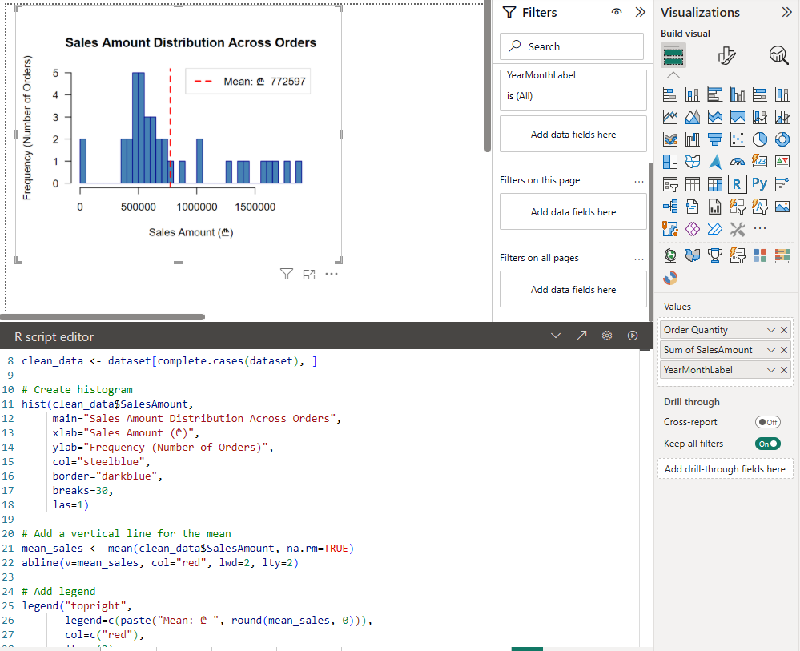
Screenshot 16. Custom R Visual - Sales Amount Distribution Histogram
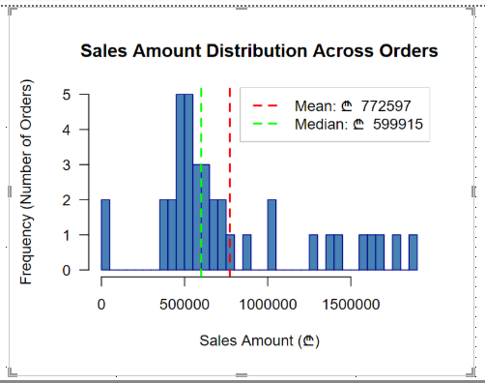
Screenshot 17. New Histogram

CONCLUSION
Task 4 demonstrated the implementation of advanced Power BI reporting techniques. The implementation of Row Level Security ensures data confidentiality across different user roles, while Bookmarks and Buttons provide intuitive navigation without page clutter. Dynamic time period switching through MTD/QTD/YTD measures enables flexible analysis, the Decomposition Tree facilitates exploratory data discovery across multiple dimensions, and custom tooltips deliver contextual insights on demand. The custom R script visual showcases the ability to extend Power BI's native capabilities with statistical analysis, demonstrating that complex analytical requirements can be met through scripting and customization. Collectively, these features create a professional, interactive, and secure reporting solution that serves both operational and analytical needs.

